- How to find the largest of three numbers using nested if in R

x<- as.integer(readline(prompt = "Enter first number :"))
y<- as.integer(readline(prompt = "Enter second number :"))
z<- as.integer(readline(prompt = "Enter third number :"))

if(x>y){
if(x>z)
print(paste("Greatest is :",x))
else
print(paste("Greatest is :",z))
}else {
if(y>z)
print(paste("Greatest is :",y))
else{
print(paste("Greatest is :",z))
}
}
OUTPUT:
Enterfirstnumber:3
Entersecondnumber:2
Enterthirdnumber:55
[1]"Greatestis:55"

- Example using switch case
A switch statement allows a variable to be tested for equality against a list of values. Each value is called a case, and the variable being switched on is checked for each case.
Syntax
The basic syntax for creating a switch statement in R is −
switch(expression, case1, case2, case3....)

Example: Illustration of switch case statement

x <-switch(
3,
"first",
"second",
"third",
"fourth"
)
print(x)

OUTPUT:
[1] "third"

- Example on for loop
Syntax:
for (value in vector) {
statements
}
Example:# Create fruit vector
fruit <- c('Apple', 'Orange',"Guava", 'Pinapple', 'Banana','Grapes')
# Create the for statement
for ( i in fruit){
print(i)
}
OUTPUT:
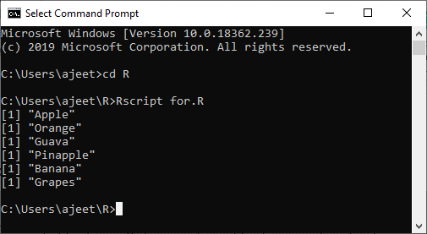
Example2: # Creating an empty list
list <- c()
# Creating a for statement to populate the list
for (i in seq(1, 5, by=1)) {
list[[i]] <- i*i
}
print(list)

Example3: # Creating a matrix
mat <- matrix(data = seq(10, 21, by=1), nrow = 6, ncol =2)
# Creating the loop with r and c to iterate over the matrix
for (r in 1:nrow(mat))
for (c in 1:ncol(mat))
print(paste("mat[", r, ",",c, "]=", mat[r,c]))
print(mat)

Example 4:# Create a list with three vectors
fruit <- list(Basket = c('Apple', 'Orange',"Guava", 'Pinapple', 'Banana','Grapes'),
Money = c(10, 12, 15), purchase = TRUE)
for (p in fruit)
{
print(p)
}

- Program to find the sum of the digits of the number.
n<-readline(prompt="please enter any integer value: ")
please enter any integer value: 12367906
n <- as.integer(n)
sum<-0
while(n!=0){
sumsum=sum+(n%%10)
n=as.integer(n/10)
}
cat("sum of the digits of the numbers is=",sum)

OUTPUT:
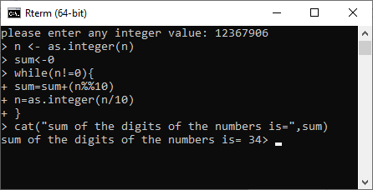
- Program to check a number is palindrome or not.
n <- readline(prompt="Enter a four digit number please: ")
n <- as.integer(n)
num<-n
rev<-0
while(n!=0){
rem<-n%%10
rev<-rem+(rev*10)
n<-as.integer(n/10)
}
print(rev)
if(rev==num){
cat(num,"is a palindrome num")
}else{
cat(num,"is not a palindrome number")
}

OUTPUT:
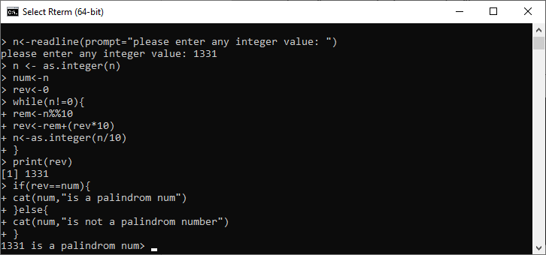

R repeat loop
A repeat loop is used to iterate a block of code. It is a special type of loop in which there is no condition to exit from the loop. For exiting, we include a break statement with a user-defined condition. This property of the loop makes it different from the other loops.
A repeat loop constructs with the help of the repeat keyword in R. It is very easy to construct an infinite loop in R.
The basic syntax of the repeat loop is as follows:
repeat {
commands
if(condition) {
break
}
}
Example1:
v <- c("Hello","repeat","loop")
cnt <- 2
repeat {
print(v)
cnt <- cnt+1

if(cnt > 5) {
break
}
}
Output
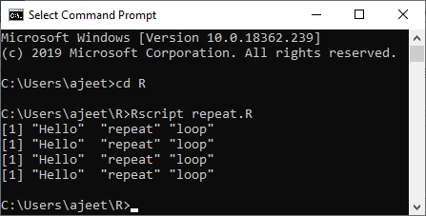
Example 2:
sum <- 0
{
n1<-readline(prompt="Enter any integer value below 20: " )
n1<-as.integer(n1)
}
repeat{
sum<-sum+n1
n1n1=n1+1
if(n1>20){
break
}
}
cat("The sum of numbers from the repeat loop is: ",sum)
Output
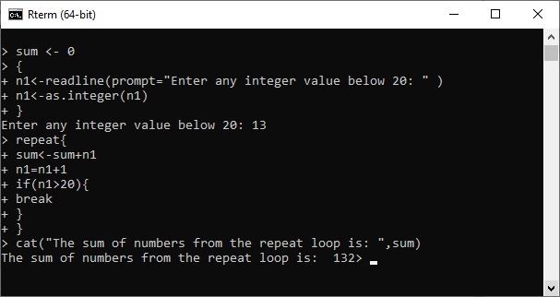

R next Statement (Like continue statement in C)
The next statement is used to skip any remaining statements in the loop and continue executing. In simple words, a next statement is a statement which skips the current iteration of a loop without terminating it. When the next statement is encountered, the R parser skips further evaluation and starts the next iteration of the loop.

Example 1: next in repeat loop
a <- 1
repeat {
if(a == 10)
break
if(a == 5){
next
}
print(a)
a <- a+1
}
Output:
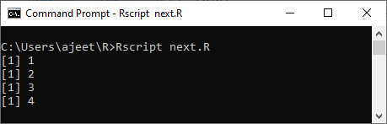

Example 2: next in while loop
a<-1
while (a < 10) {
if(a==5)
next
print(a)
a = a + 1
}
Output:
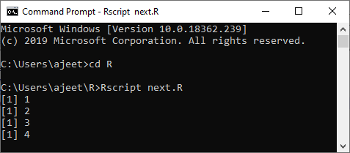

R Break Statement
In the R language, the break statement is used to break the execution and for an immediate exit from the loop. In nested loops, break exits from the innermost loop only and control transfer to the outer loop.

Example 1: Break in repeat loop
a <- 1
repeat {
print("hello");
if(a >= 5)
break
a<-a+1
}
Output:
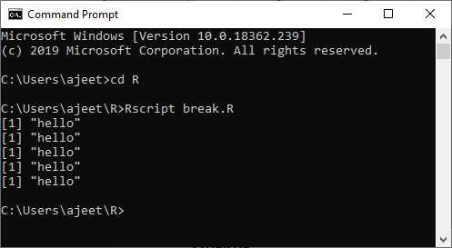

Example 2
v <- c("Hello","loop")
count <- 2
repeat {
print(v)
count <- count + 1
if(count > 5) {
break
}
}
Output:
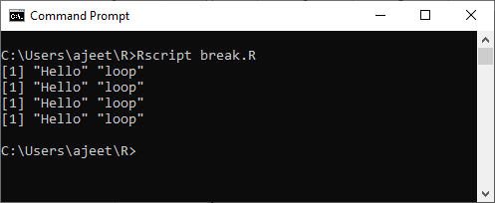

Example 3: Break in while loop
a<-1
while (a < 10) {
print(a)
if(a==5)
break
a = a + 1
}
Output:
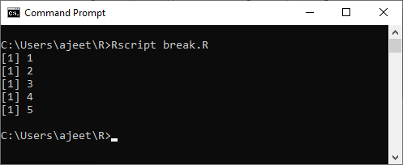
- Functions in R:
"An R function is created by using the keyword function." There is the following syntax of R function:
func_name <- function(arg_1, arg_2, ...) {
Function body
}
Similar to the other languages, R also has two types of function, i.e. Built-in Function and User-defined Function. In R.
The functions which are already created or defined in the programming framework are known as built-in functions.
R have different types of built-in functions such as seq(), mean(), max(), and sum(x) etc.
# Creating sequence of numbers from 32 to 46.
print(seq(32,46))

# Finding the mean of numbers from 22 to 80.
print(mean(22:80))

# Finding the sum of numbers from 41 to 70.
print(sum(41:70))
Output:
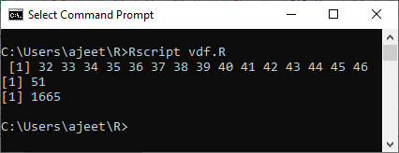
R allows us to create our own function in our program. A user defines a user-define function to fulfill the requirement of user. Once these functions are created, we can use these functions like in-built function.
# Creating a function without an argument.
new.function <- function() {
for(i in 1:5) {
print(i^2)
}
}
new.function()
Output:
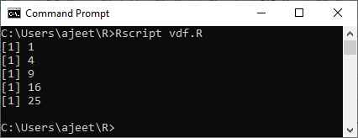

Function calling with an argument
We can easily call a function by passing an appropriate argument in the function. Let see an example to see how a function is called.
# Creating a function to print squares of numbers in sequence.
new.function <- function(a) {
for(i in 1:a) {
b <- i^2
print(b)
}

# Calling the function new.function supplying 10 as an argument.
new.function(10)

